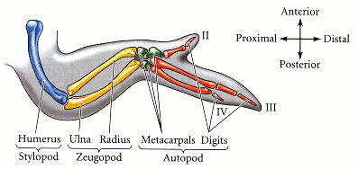
Figure 16.1. Skeletal pattern of the chick wing. According to convention, the digits are numbered II, III, and IV. (Digits I and V are not found in chick wings.)

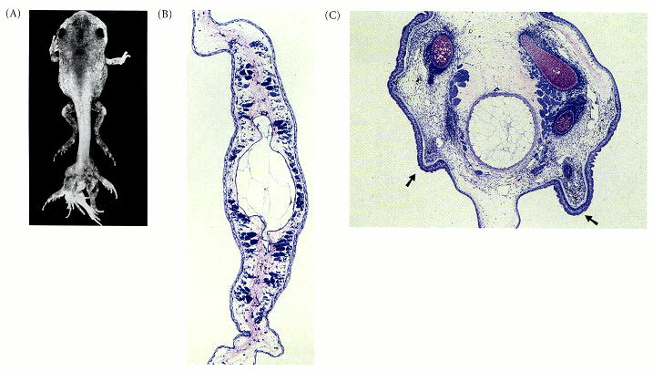
Figure 16.2. Legs regenerating from retinoic acid-treated tadpole tail. (A) The tail stump of a balloon frog tadpole treated with retinoic acid after amputation will form limbs from the amputation site. (B) Normal tail regeneration in a Rana temporaria tadpole 4 weeks after amputation. A small neural tube can be seen above a large notochord, and the muscles are arranged in packets. No cartilage or bone is present. (C) A retinoic acid-treated tadpole tail makes limb buds (arrows) as well as pelvic cartilage and bone. The cartilaginous rudiment of the femur can be seen in the right limb bud. (A from Mohanty-Hejmadi et al. 1992, courtesy of P. Mohanty-Hejmadi; B and C from Müller et al. 1996, courtesy of G. Müller.)

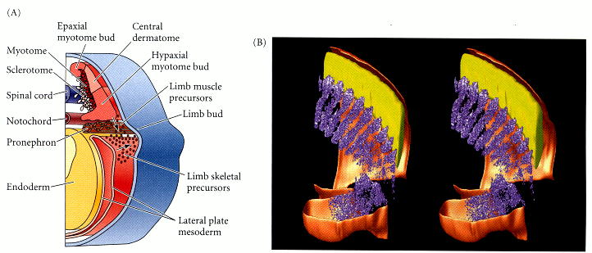
Figure 16.3. Limb bud formation. (A) Proliferation of mesodermal cells from the somatic region of the lateral plate mesoderm causes the limb bud in the amphibian embryo to bulge outward. These cells generate the skeletal elements of the limb. Contributions of cells from the myotome provide the source of the limb's musculature. (B) Entry of myotome cells (purple) into the limb bud. This computer reconstruction was made from sections from an in situ hybridization to the myf5 mRNA found in developing muscle cells. If you can cross your eyes, the three-dimensionality of the stereogram will become apparent. (B courtesy of J. Streicher and G. Müller.)

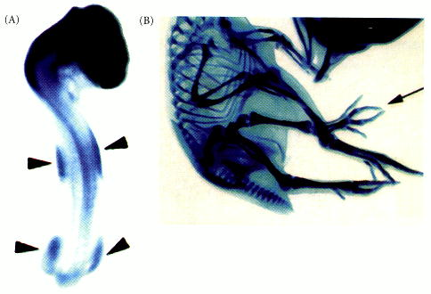
Figure 16.4. FGF10 expression and action in the developing chick limb. (A) FGF10 becomes expressed in the lateral plate mesoderm in precisely those positions where limbs normally form. (B) When cells genetically constructed to secrete FGF10 are placed into the flanks of chick embryos, the FGF10 can cause the formation of an ectopic limb (arrow). (From Ohuchi et al. 1997; courtesy of S. Noji.)

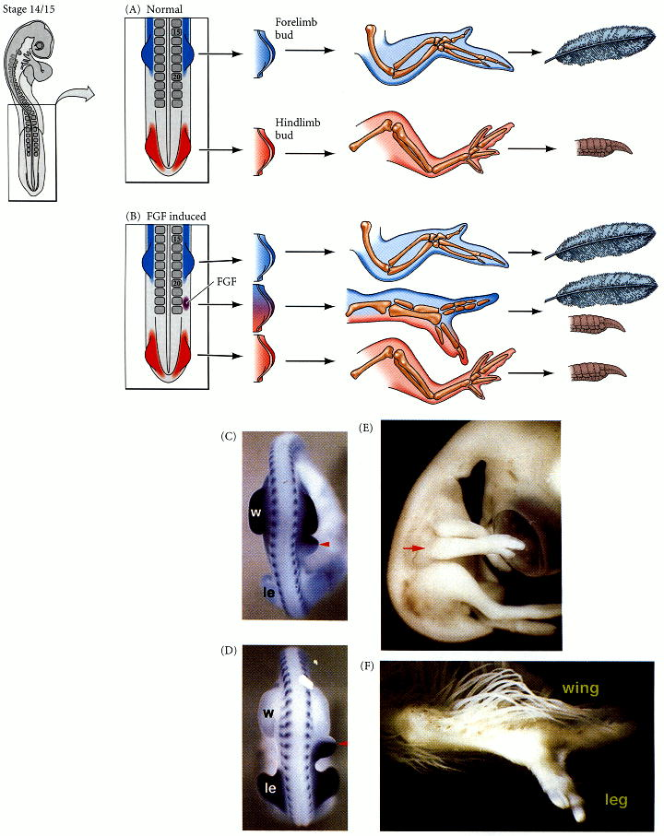
Figure 16.5. Specification of limb type by Tbx4 and Tbx5. (A) During normal chick development, in situ hybridizations show that Tbx5 is found in the anterior lateral plate mesoderm, while Tbx4 is found in the posterior lateral plate mesoderm. Tbx5-containing limb buds produce wings, while Tbx4-containing limb buds generate legs. (B) If a new limb bud is induced with an FGF-secreting bead, the type of limb formed depends upon the tbx gene expressed in the limb bud. If placed between the regions of Tbx4 and Tbx5 expression, the bead will induce the expression of Tbx4 posteriorly and Tbx5 anteriorly. The resulting limb bud will also express Tbx5 anteriorly and Tbx4 posteriorly and will generate a chimeric limb. (C) Expression of Tbx5 in the forelimb (w, wing) buds and in the anterior portion of a limb bud induced by an FGF-secreting bead. (The somite level can be determined by staining for Mrf4 mRNA, which is localized to the myotomes.) (D) Expression of Tbx4 in the hindlimb (le, leg) buds and in the posterior portion of an FGF-induced limb bud. (E, F) A chimeric limb induced by an FGF bead contains anterior wing structures and posterior leg structures. (A, B after Ohuchi et al. 1998, Ohuchi and Noji 1999; C-F photographs courtesy of S. Noji.)

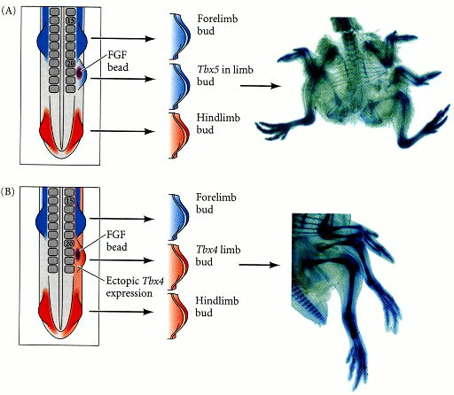
Figure 16.6. Respecification of forelimb into hindlimb by ectopic expression of Tbx4. (A) An FGF-secreting bead opposite somite 21 usually induces a Tbx5-expressing limb bud that forms a new wing. (B) If the entire flank is experimentally made to express Tbx4 (by infecting it with a Tbx4-expressing virus), the FGF-induced limb bud expresses Tbx4, and often becomes a leg. (After Rodriguez-Esteban et al. 1999; photographs courtesy of J. C. Izpisúa-Belmonte.

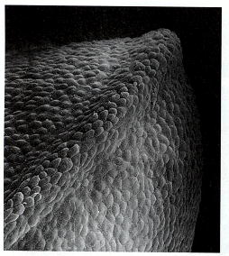
Figure 16.7. Scanning electron micrograph of an early chick forelimb bud, with its apical ectodermal ridge in the foreground. (Courtesy of K. W. Tosney.)

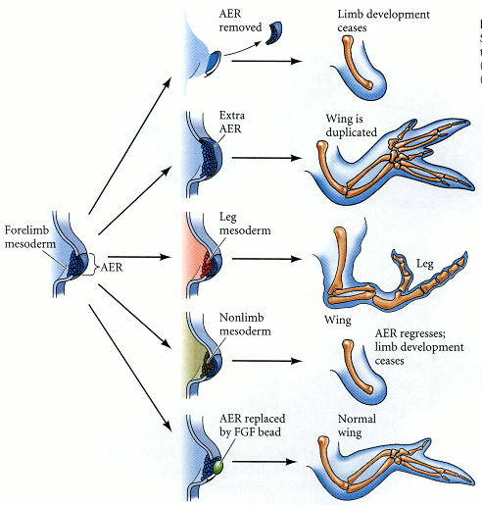
Figure 16.8. Summary of experiments demonstrating the effect of the apical ectodermal ridge (AER) on the underlying mesenchyme. (Modified from Wessells 1977.)

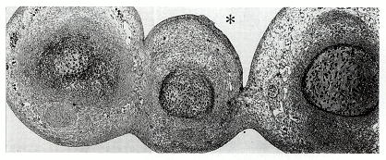
Figure 16.9. Cross section through the distal region of a chick limb 3 days after a wedge of the AER was removed from an area that would normally form interdigital tissue. Instead of degenerating, the remaining interdigital tissue formed an extra digit (marked by an asterisk). (From Hurle et al. 1989; photograph courtesy of the authors.)

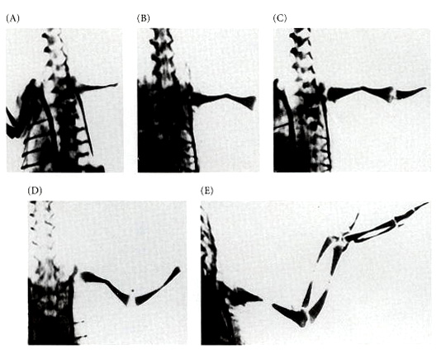
Figure 16.10. Dorsal view of chick skeletal pattern after removal of the entire AER from the right wing bud of chick embryos at various stages. The last photo (E) is of a normal wing skeleton. (From Iten 1982; photographs courtesy of L. Iten.)

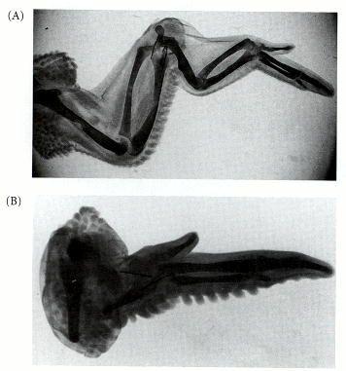
Figure 16.11. Control of proximal-distal specification by the cells of the progress zone. (A) Extra set of ulna and radius formed when an early-bud progress zone was transplanted to a late wing bud that had already formed ulna and radius. (B) Lack of intermediate structures seen when a late-bud progress zone was transplanted to an early limb bud. The hinges indicate the locations of the grafts. (From Summerbell and Lewis 1975; photographs courtesy of D. Summerbell.)

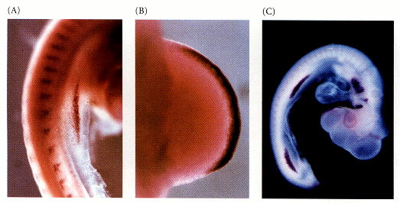
Figure 16.12. FGF8 in the AER. (A) In situ hybridization showing expression of Fgf8 message in the ectoderm as the limb bud begins to form. (B) Expression of Fgf8 RNA in the apical ectodermal ridge, the source of mitotic signals to the underlying mesoderm. (C) In normal 3-day chick embryos, FGF8 is expressed in the apical ectodermal ridge of both the forelimb and hindlimb buds. It is also expressed in several other places in the embryo including the pharyngeal arches. (A and B courtesy of J. C. Izpisúa-Belmonte; C courtesy of A. López-Martínez and J. F. Fallon.)

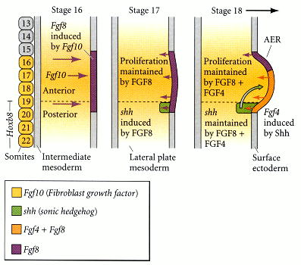
Figure 16.13. A molecular model for the initiation of the limb bud. FGF10 secreted by the lateral plate mesoderm induces FGF8 expression in the competent ectoderm at the dorsal-ventral boundary. The anterior-posterior boundary is present at stage 16 (and perhaps earlier). The FGF8 secretion by the ectoderm induces the proliferation of the mesenchyme cells and induces Sonic hedgehog expression in the posterior region of the limb bud. Sonic hedgehog induces FGF4 expression in the posterior portion of the limb bud ectoderm. FGF2 is also made by the AER ectoderm, although it is not yet clear whether it is induced by the FGF10.

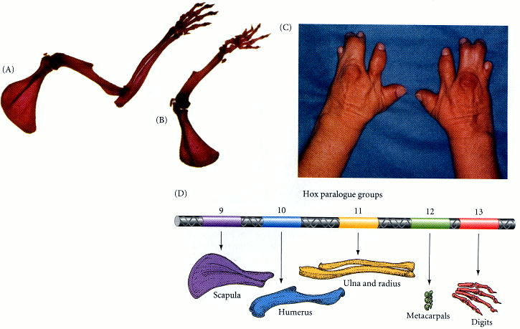
Figure 16.14. Deletion of limb bone elements by the deletion of paralogous Hox genes. (A) Wild-type mouse forelimb. (B) Forelimb of mouse made doubly mutant such that it lacked functional Hoxa-11 and Hoxd-11 genes. The ulna and radius are absent. (C) Human synpolydactyly (many fingers joined together) syndrome resulting from homozygosity at the HOXD-13 loci. The human syndrome also includes malformations of the urogenital system, which also expresses HOXD-13. (D) Hypothesis that the 5´ paralogues of Hox genes specify particular regions of the forelimb. (A, B, and D after Davis et al. 1995, photographs courtesy of M. Capecchi; C from Muragaki et al. 1996, photograph courtesy of B. Olsen.)

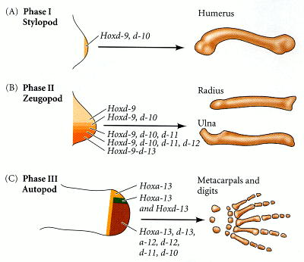
Figure 16.15. Hox gene expression changes during the formation of the tetrapod limb. (A) During the formation of the stylopod (phase I), Hoxd-9 and Hoxd-10 are expressed in the newly formed limb bud. (B) During zeugopod formation (phase 2), there is a nested expression of Hoxd genes such that Hoxd-9 through Hoxd-13 are expressed in the posterior of the limb bud, while only Hoxd-9 is expressed both anteriorly and posteriorly. (C) Inversion of Hox gene expression during autopod formation. Hoxd-13 and Hoxa-13 are expressed anteriorly and posteriorly, while Hoxd-10 through Hoxd-12 and Hoxa-12 are expressed posteriorly. (After Shubin et al. 1997.)

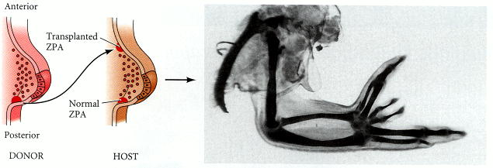
Figure 16.17. When a ZPA is grafted to anterior limb bud mesoderm, duplicated digits emerge as a mirror image of the normal digits. (From Honig and Summerbell 1985; photograph courtesy of D. Summerbell.)

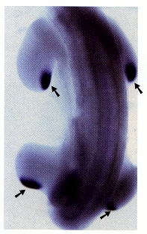
Figure 16.18. In situ hybridization showing the sites of Sonic hedgehog expression (arrows) in the posterior mesoderm of the chick limb buds. These are precisely the regions that transplantation experiments defined as the ZPA. (Photograph courtesy of R. D. Riddle.)

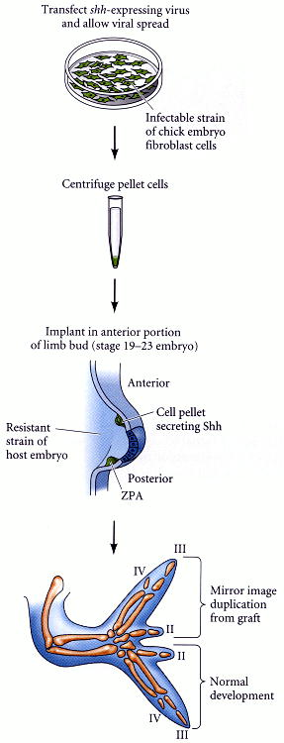
Figure 16.19. Assay for polarizing activity of Sonic hedgehog. The sonic hedgehog gene was inserted adjacent to an active promoter of a chicken virus, and the recombinant virus was placed into cultured chick embryo fibroblast cells (CEF). The virally infected cells were pelleted and implanted into the anterior margin of a limb bud of a chick embryo. The resulting limbs produced mirror-image digits, showing that the secreted protein had polarizing activity. (After Riddle et al. 1993.)

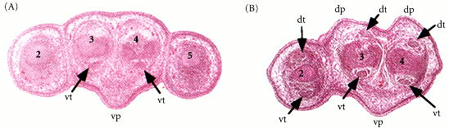
Figure 16.20. Dorsal-to-ventral transformations of limb regions in mice deficient for both Wnt7a genes. (A) Histological section (stained with hemotoxylin and eosin) of wild-type 15.5-day embryonic mouse forelimb paw. The ventral tendons and ventral footpads are readily seen. (B) Same section through a mutant embryo deficient in Wnt7a. Tendons and footpads are duplicated on what would normally be the dorsal surface of the paw. dt, dorsal tendons; dp, dorsal footpad; vp, ventral footpad; vt, ventral tendon. Numbers indicate digit identity. (From Parr and McMahon 1995; photographs courtesy of the authors.)

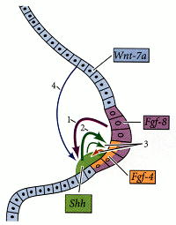
Figure 16.21. Some of the molecular interactions by which limb bud formation is initiated and maintained. Some of the major loops include (1) the establishment of the ZPA (Sonic hedgehog) by the AER (FGF8); (2) the induction of FGF4 (in the AER) by Sonic hedgehog (in the ZPA); (3) the mutual maintenance of FGF4 and Sonic hedgehog; and (4) the maintenance of Sonic hedgehog by Wnt7a (in the dorsal ectoderm). The broad arrows indicate induction; the finer arrows indicate maintenance. (After Pearse and Tabin 1998.)

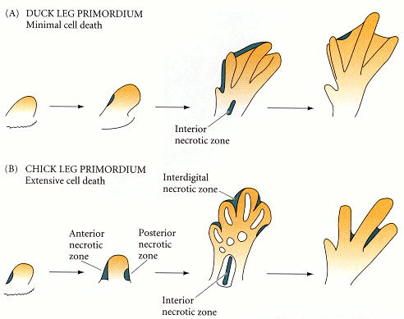
Figure 16.22. Patterns of cell death in leg primordia of (A) duck and (B) chick embryos. Shading indicates areas of cell death. In the duck, the regions of cell death are very small, whereas there are extensive regions of cell death in the interdigital tissue of the chicken leg. (After Saunders and Fallon 1966.)

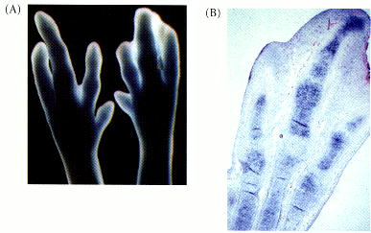
Figure 16.23. Blocking the BMP receptor can prevent apoptosis in the chick autopod. (A) The left limb bud was untreated, while the right limb bud was infected with a virus that transcribed a dominant negative BMP receptor. This mutant receptor blocked BMP signaling in the right limb bud and prevented apoptosis and digit growth. (B) noggin expression in developing leg digits. This protein is expressed in the regions of cartilage condensation and is absent from the regions of interdigital apoptosis and joint formation at this stage.

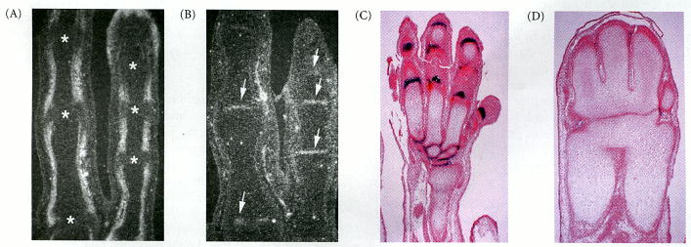
Figure 16.24. Possible involvement of BMPs in stabilizing cartilage and forming joints. (A, B) Expression pattern of (A) BMP7 and (B) BMP2 in two consecutive microscopic sections of chick digits III and IV during a late stage of limb formation. The asterisks in (A) and the arrows in (B) denote places where joints will form. (C, D) The effects of Noggin. (C) 16.5-day autopod from a wild-type mouse, showing GDF5 expression (dark blue) at the joints. (D) 16.5-day noggin-deficient mutant mouse autopod, showing neither joints nor GDF5 expression. Presumably, in the absence of Noggin, BMP7 was able to convert nearly all the mesenchyme into cartilage.

